Project 4

CIS 435

12/11/2018

**Roles:**

Hassan Mehdi – Javascript and database

Veeram Hirahkan – html, CSS and report

Joshua Attard – PHP and database

**Design Considerations:**

We designed our project with a clean user experience in mind. Being able to select the quantity of items you wanted with button clicks, and seeing your total bill at the bottom, only having to enter your name for the pickup order and clicking enter.

We used JavaScript to dynamically update the price on each click. and a form to collect the final price and name of the order on submission to be used in the php function

**UI Mockup**

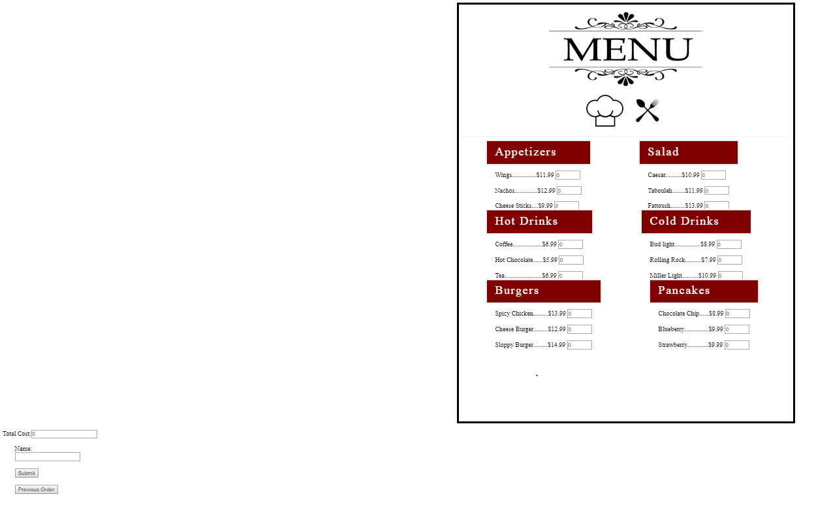

**Sequence Diagram**

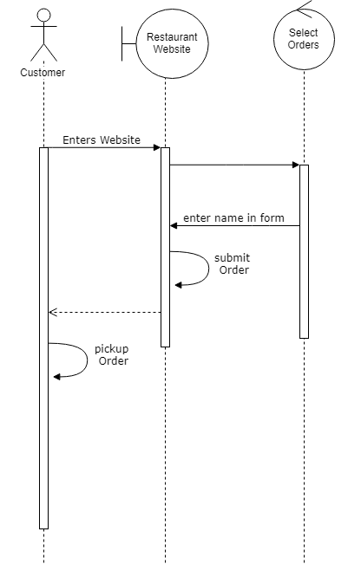

**Summary:**

In conclusion, we sharpened our skills in all of the following: html, CSS, javascript, php, and sql. Furthermore we learned to use them all to deliver a cohesive and useable project.

**Tutorial**

1. Enter the website and select what you want to order

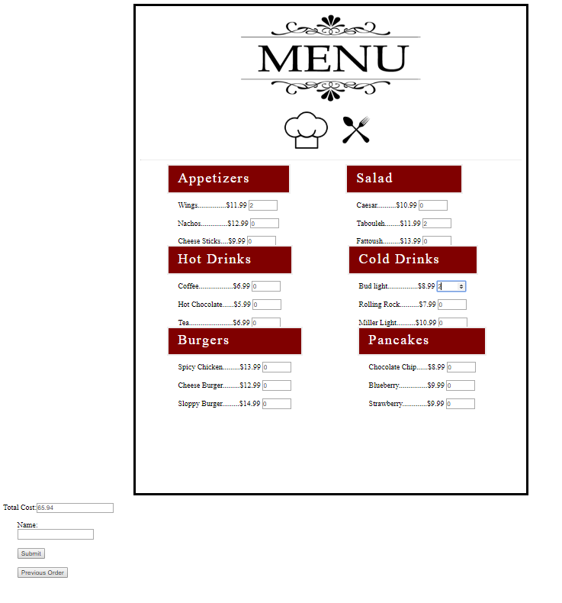

1. After selection enter the name of your order for pickup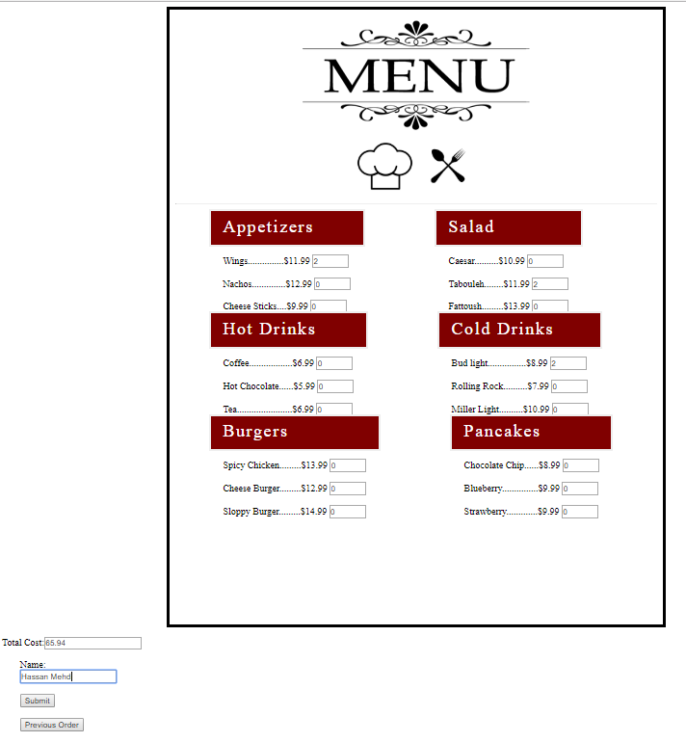
2. click submit for your order to be process



1. last of all, pick up your order

(NOTE: The image is not connected to our brand in any way shape or form and is only presented for demonstration puposes) 